Data Ingestion from a REST API to Azure Storage using Azure Data Factory
The activity demonstrated in the provided steps is setting up an ETL (Extract, Transform, Load) pipeline in Azure Data Factory. Specifically, it involves creating a "Copy data" activity to extract local search result data from a REST API (Apple Maps API via SearchApi) and ingest the resulting JSON payload into a designated container within an Azure Data Lake Storage Gen2 account.
- Apple MapsAI-https://www.searchapi.io/api/v1/search?engine=apple_maps

- https://www.searchapi.io/api/v1/search?engine=apple_maps&q=McDonald's&center=40.712776,-74.005974&zoom12&api_key=2X9Q2VdiyqbwNDcBVrs6L4pa

- Review the SearchApi documentation for the Apple Maps API to identify the required endpoint and formulate your query parameters (e.g., engine=apple_maps, q=McDonald's, and specific center coordinates).
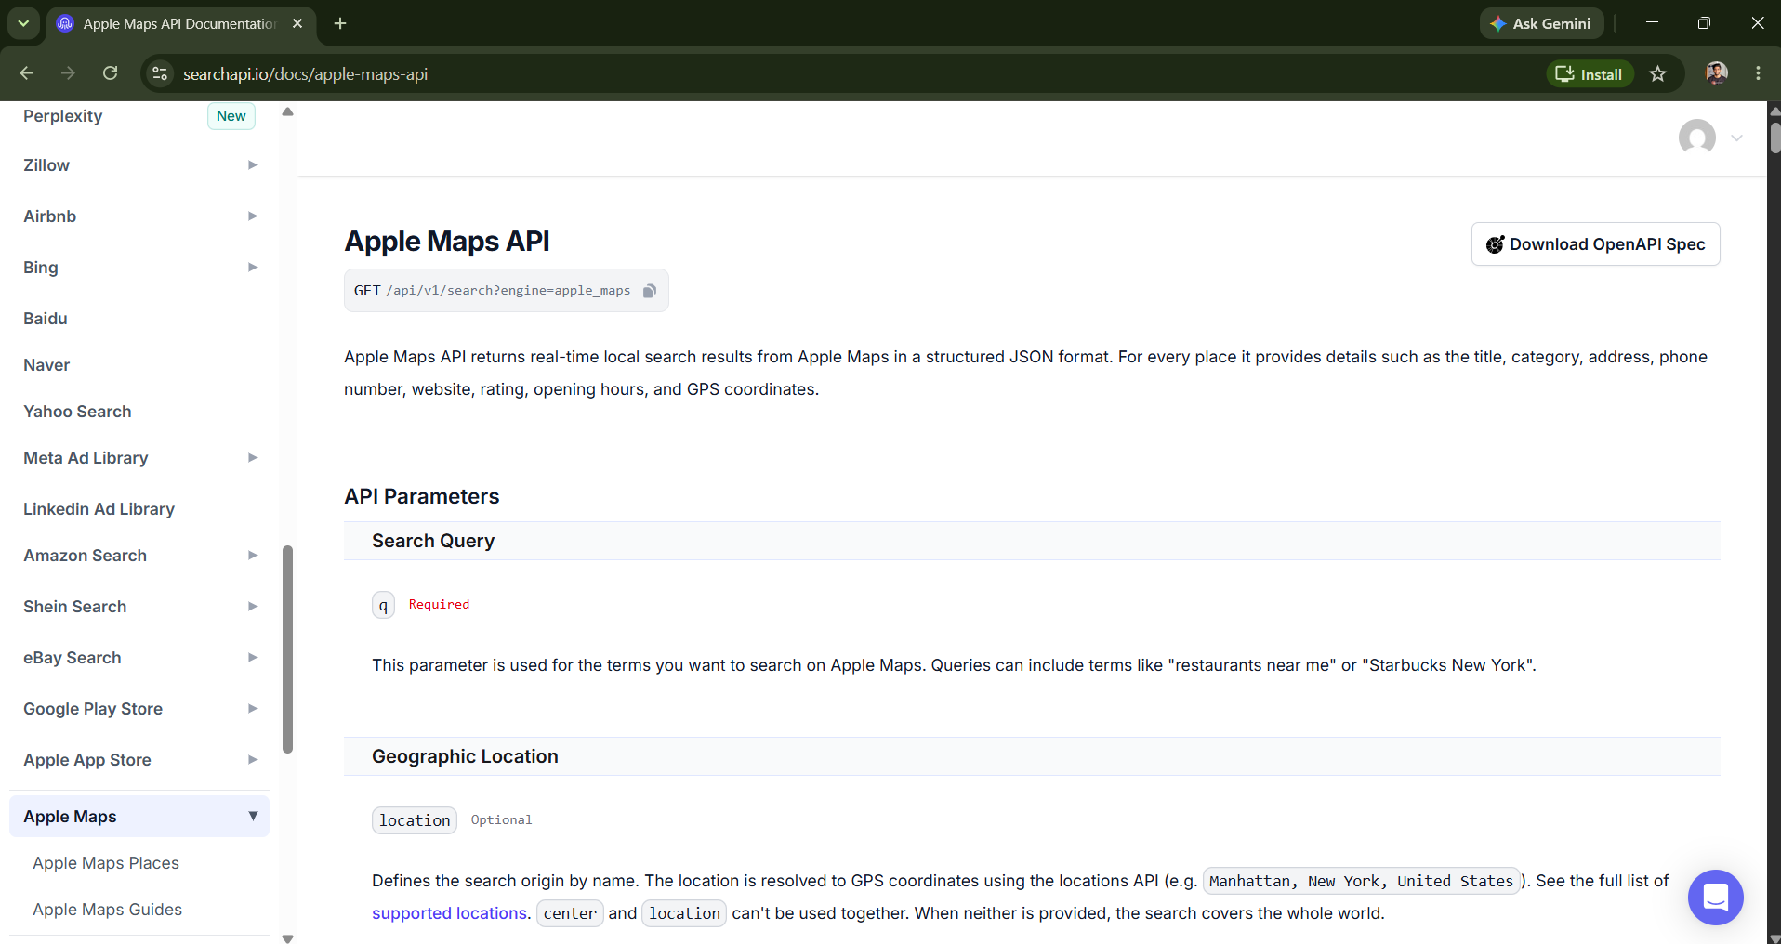

- Open the Azure Portal and navigate to your designated resource group (e.g., evan12345) that houses your Azure Data Factory and Azure Storage Account resources.
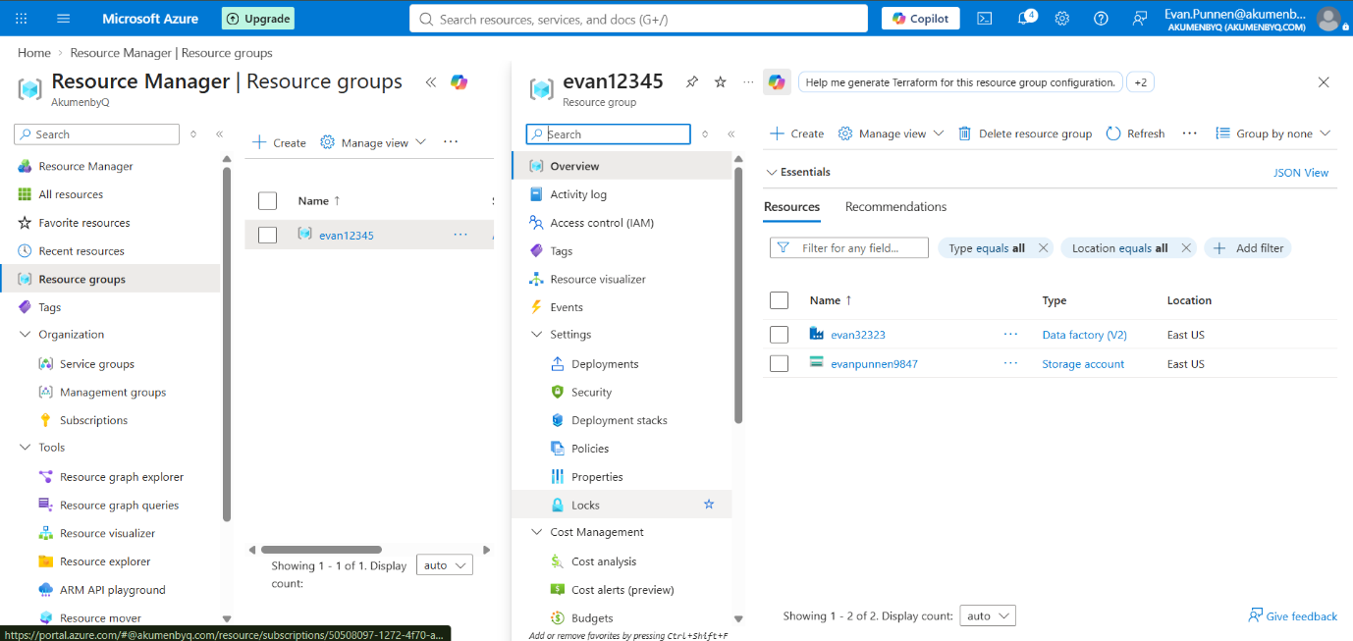
- Launch Azure Data Factory Studio, navigate to the Manage tab under Connections, and view your Linked services to prepare both the source and sink connections.
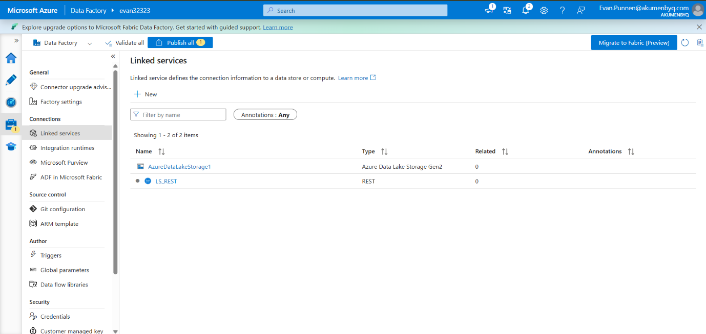
- Create and configure a new REST Linked Service (LS_REST). Input the Base URL ([https://www.searchapi.io/api/v1](https://www.searchapi.io/api/v1)) and set the Authentication type to Anonymous.

- Set up a REST dataset (S_REST) using the linked service. Define the Relative URL with your specific search parameters to target the exact Apple Maps query.
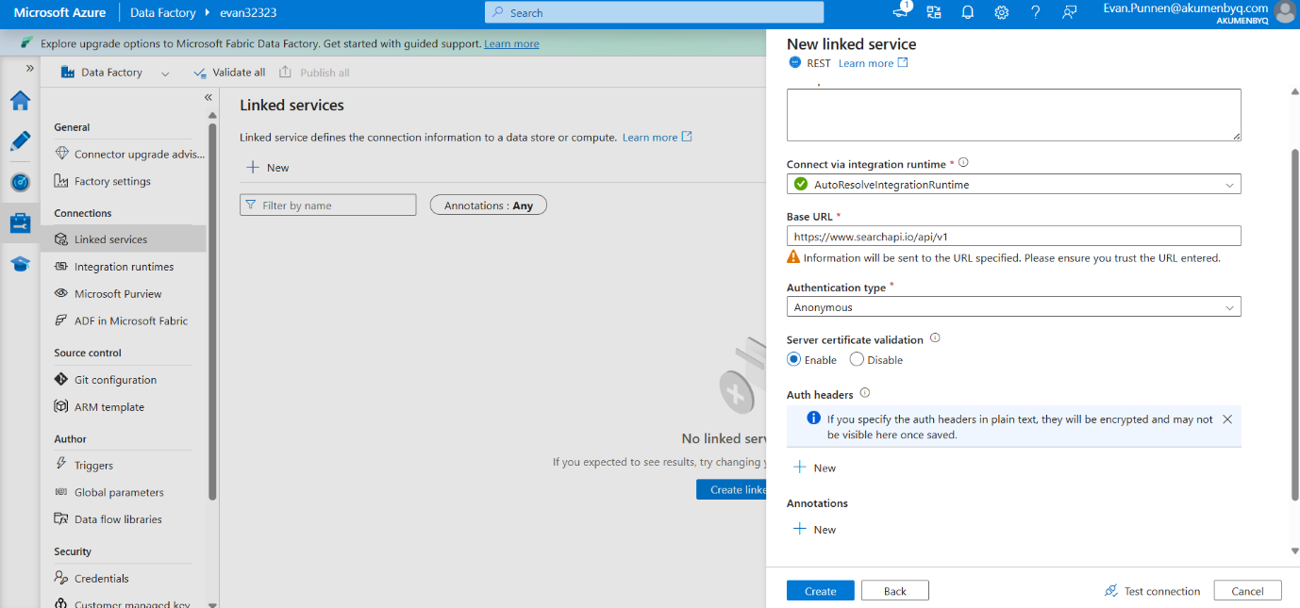
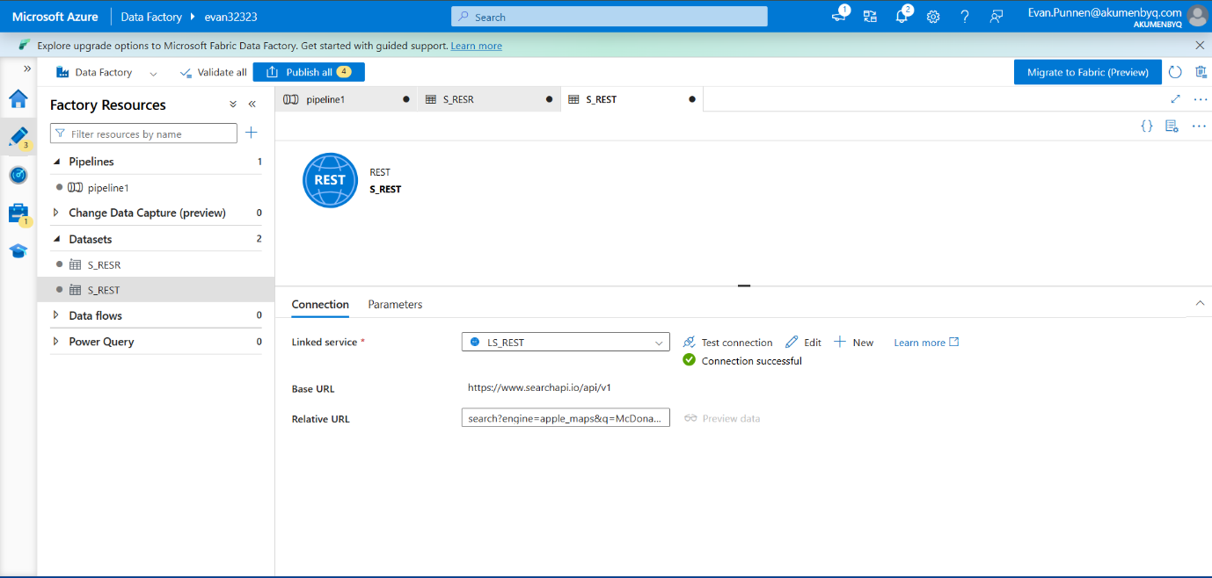
- Use the Preview data feature within the dataset configuration to test the connection and ensure the API successfully returns the structured JSON payload.
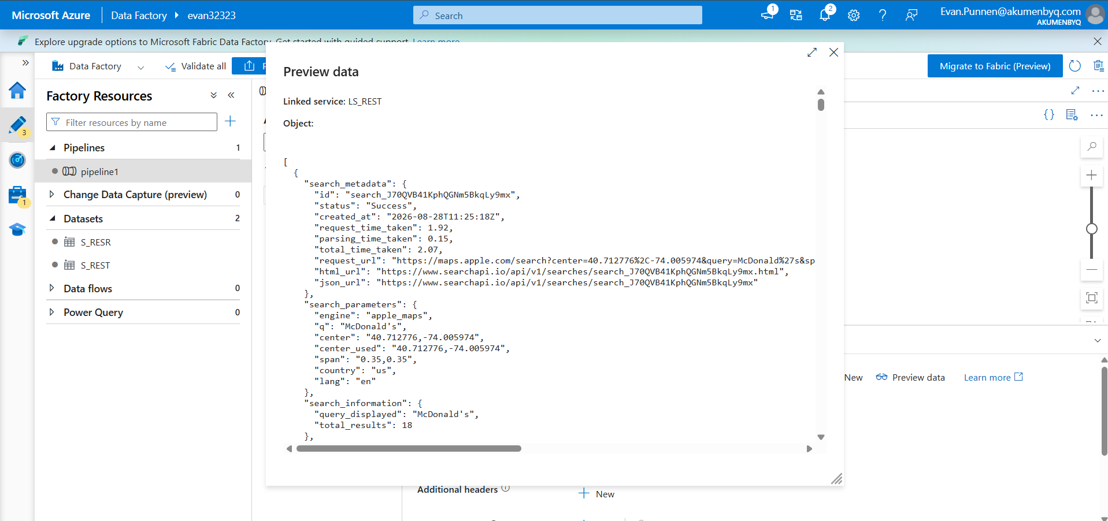

- Create a pipeline (pipeline1) featuring a Copy data activity. Set the REST dataset as the source, trigger a debug run, and verify the activity status marks as Succeeded.

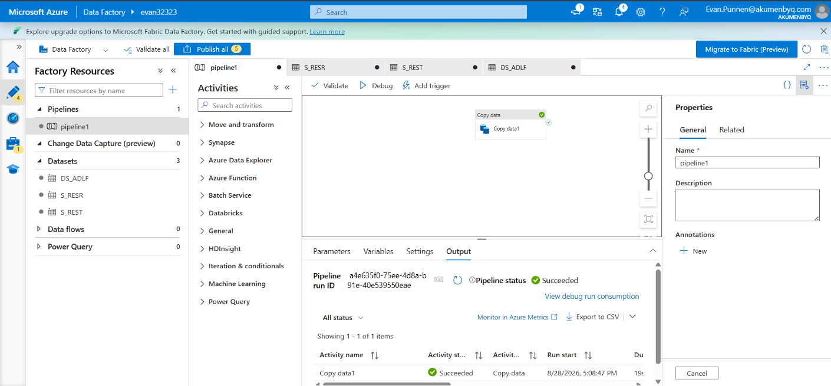

- Configure the sink dataset (DS_ADLF) for the Copy activity using your Azure Data Lake Storage Gen2 linked service. Specify the exact File path for the destination (e.g., output/applemaps/applemaps.json).
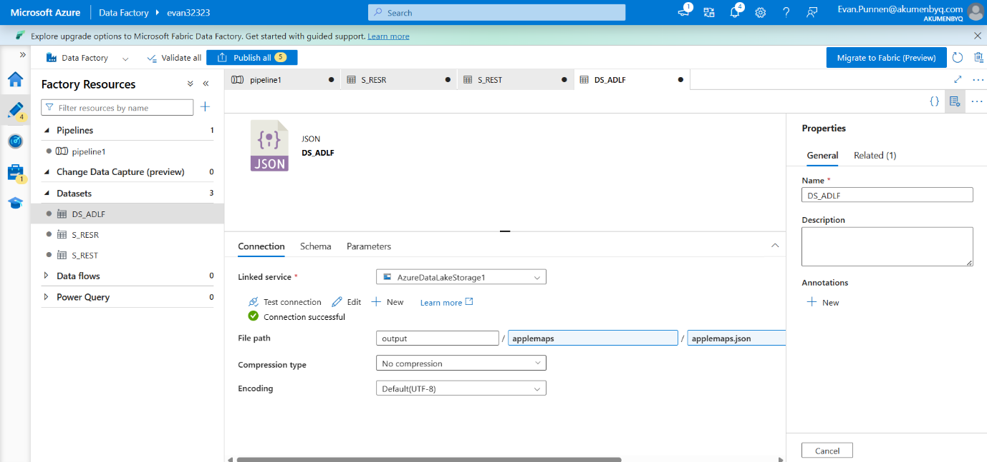
- Return to the Azure Portal, open your target Storage Account, and navigate to the designated container (e.g., output) to verify the new folder creation.
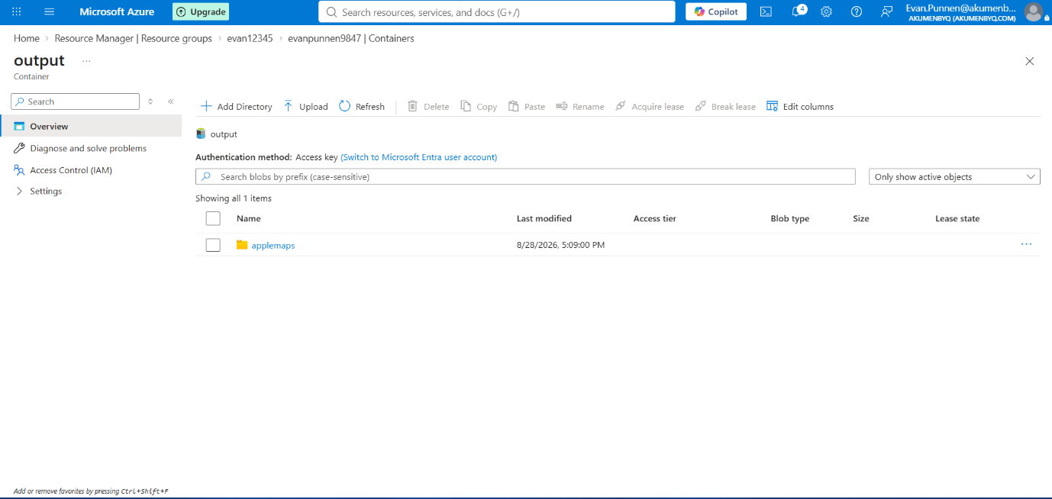
- Open the newly created folder (applemaps) to confirm the applemaps.json blob file has been successfully generated and stored by the pipeline.
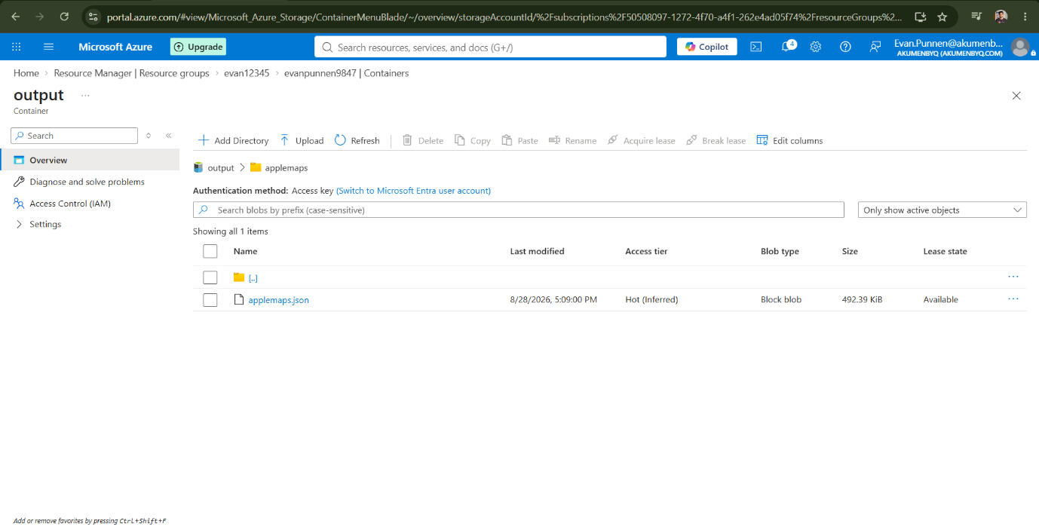
- Select the applemaps.json blob and open the Edit tab within the portal to inspect the raw JSON output and confirm it matches the API response.
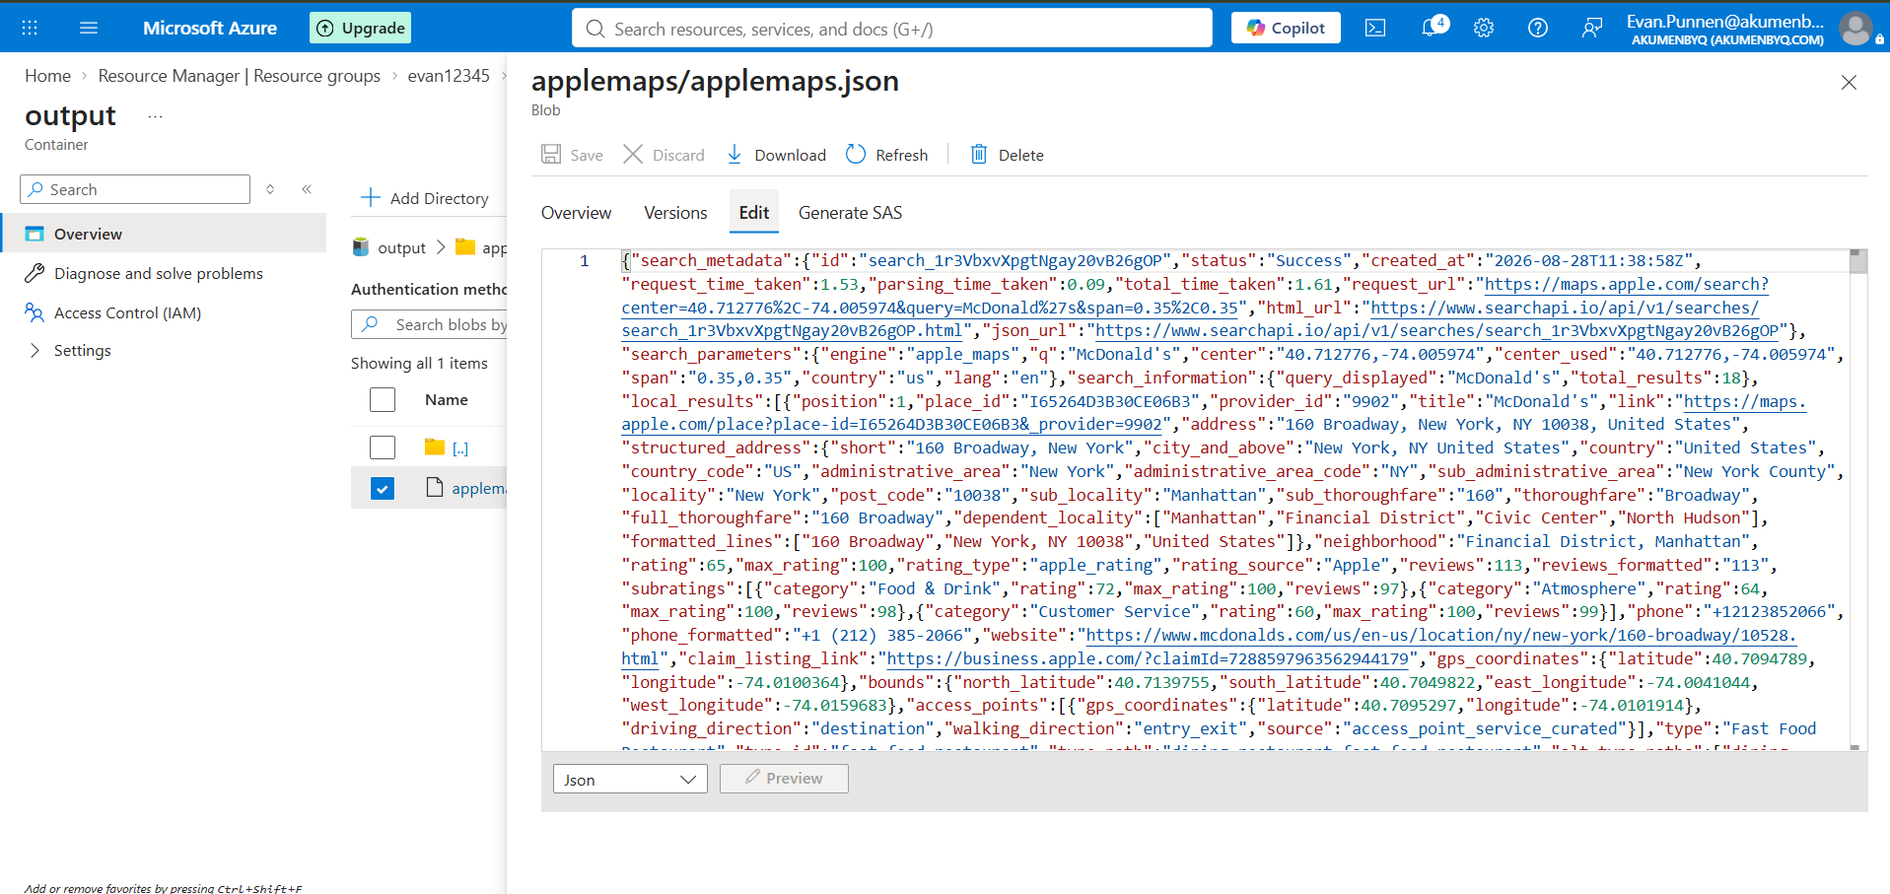

- Download and open the JSON file in a dedicated viewer to easily parse the nested structure, including search_metadata, search_parameters, and local results.

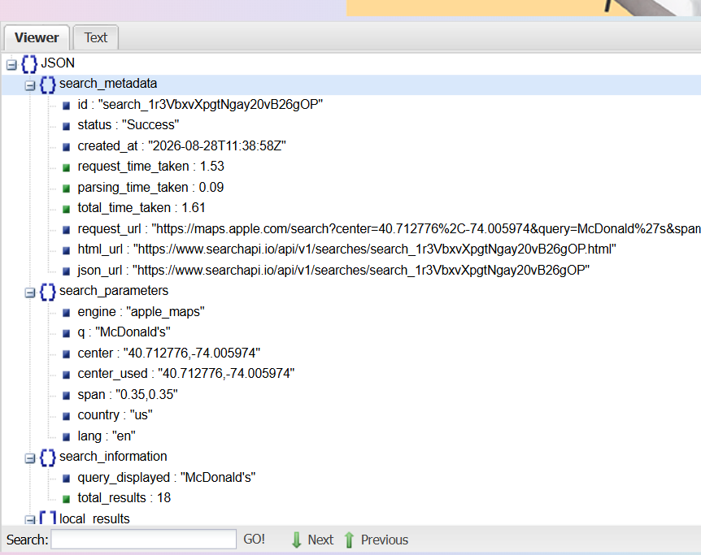
- Cross-reference the extracted location data (like coordinates and addresses) with the live Apple Maps interface to validate the real-world accuracy of the dataset.
